CSC258 Pre-lab #1

Part I

1)

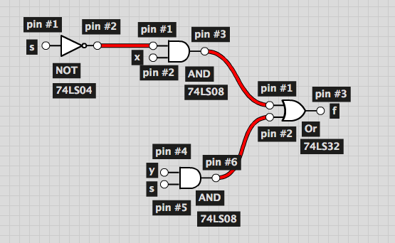

2)

|  |  |  |  |  |  |  |
| --- | --- | --- | --- | --- | --- | --- |
| X | S | S’ | **XS’** | Y | **YS** | XS’ + YS |
| 0 | 0 | 1 | **0** | 0 | **0** | 0 |
| 1 | 0 | 1 | **0** | 0 | **0** | 0 |
| 0 | 1 | 0 | **0** | 0 | **0** | 0 |
| 0 | 0 | 1 | **0** | 1 | **0** | 0 |
| 1 | 1 | 0 | **1** | 0 | **0** | 1 |
| 1 | 0 | 1 | **0** | 1 | **0** | 0 |
| 0 | 1 | 0 | **0** | 1 | **1** | 1 |
| 1 | 1 | 0 | **1** | 1 | **1** | 1 |

Part II

1)

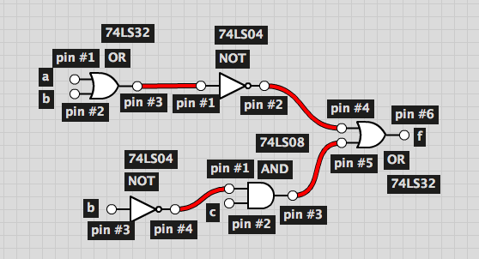

2)

|  |  |  |  |  |  |  |  |
| --- | --- | --- | --- | --- | --- | --- | --- |
| A | B | (A +B) | **(A + B)’** | C | B’ | **CB’** | (A +B)’ + CB’ |
| 0 | 0 | 0 | **1** | 0 | 1 | **0** | 1 |
| 1 | 0 | 1 | **0** | 0 | 1 | **0** | 0 |
| 0 | 1 | 1 | **0** | 0 | 0 | **0** | 0 |
| 0 | 0 | 0 | **1** | 1 | 1 | **1** | 1 |
| 1 | 1 | 1 | **0** | 0 | 0 | **0** | 0 |
| 1 | 0 | 1 | **0** | 1 | 1 | **1** | 1 |
| 0 | 1 | 1 | **0** | 1 | 0 | **0** | 0 |
| 1 | 1 | 1 | **0** | 1 | 0 | **0** | 0 |

3)

f = (a + b)’ + cb’

= a’b’ + c’b’

= b’(a’ + c)